CSA0564 - DATABASE MANAGEMENT SYSTEMS FOR QUERY PROCESSING

GROUP FUNCTIONS :

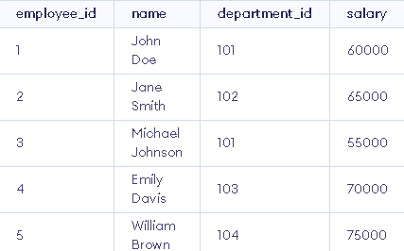

MAX :





MIN :





SUM :

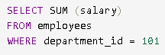



AVG :

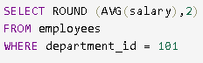



VARIANCE :





GROUP FUNCTIONS COMBINED :

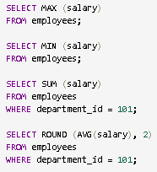

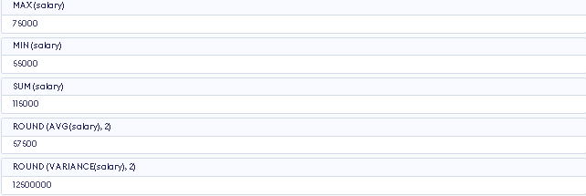

COUNT :





COUNT (\*) :

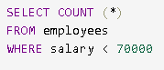



DISTINCT :



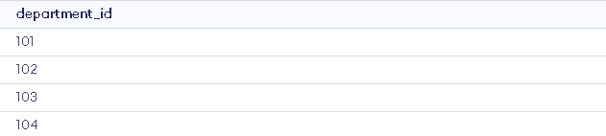



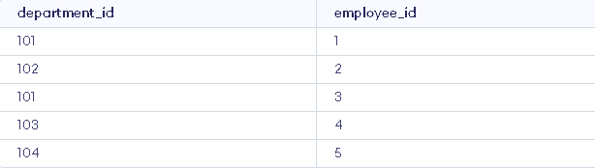

GROUP BY CLAUSE :

